“Software Analysis and Design”

1. The important advantage of the using publish-subscribe pattern is loose coupling between objects. There are one-to-many relations between subject and observers. Thus, the changes on the subject can be easily broadcasted to all observers so that observers can update them automatically.

Sequence Diagram:

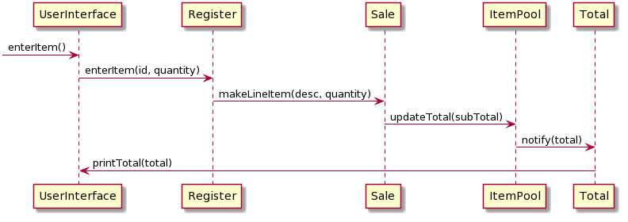Uml Diagram:

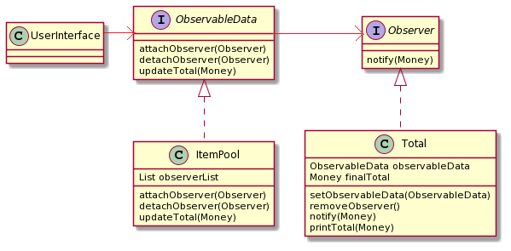

1. Failover to local services uses the combined of adapter pattern and factory method. The product adapters are implemented to retrieve product descriptions, but these classes are not in the role of adapter to another component. There are two types of product adapters, one is local service and the other is external service. Local service is implemented in the front of the external service so local service is used firstly to get product descriptions. In case of not found product description with local service, external service will be used. The purpose of the using this design is to handle the case of that the product description cannot be retrieved from remote services. This design has an advantage to recover the failover of the remote services and it uses local services to provide local caching. If the connection cannot be established, product descriptions can be accessed through local services.